Hand Gesture Controlled Fan

Description:
The Hand Gesture Controlled Fan project is designed to control a fan using hand movement without physical contact.
In this project, an IR sensor detects the presence of a hand, and a relay module is used to switch a DC motor with a propeller ON or OFF.
The system operates using a battery supply, making it suitable for basic automation and contactless control applications.

Block Diagram:
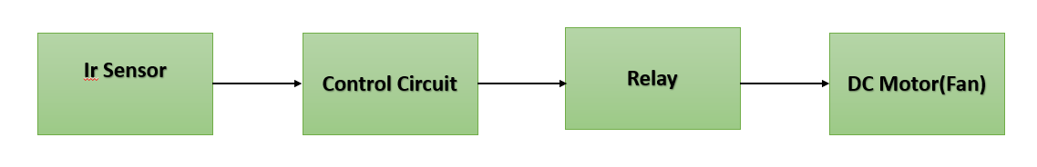

Pinout / Circuit Connection:
IR Sensor OUT → Control Input (Relay trigger / control pin)
IR Sensor VCC → Battery Supply (+)
IR Sensor GND → Battery Supply (–)
Relay COM → Battery (+)
Relay NO → DC Motor (+)
DC Motor (–) → Battery (–)
Power Supply: 5 × 1.5V cells (7.5V total)

Components Required:
Arduino Uno
DC Motor
Propeller
IR Sensor Module
Relay Module
5 × 1.5V Battery Cells
Battery Holder
Jumper wires
Breadboard

Working Principle:
The project works on the principle of infrared sensing and electromechanical switching.
When a hand is moved in front of the IR sensor, the reflected infrared rays are detected.
The IR sensor output activates the relay module.
The relay acts as a switch, allowing battery power to reach the DC motor.
The motor rotates the propeller, acting as a fan.
When the hand is removed, the relay turns OFF, stopping the motor.
Operation (Step-by-Step):
- Connect the IR sensor, relay, and motor as per the circuit diagram.
- Fix the propeller to the DC motor shaft.
- Insert the 1.5V cells into the battery holder.
- Power ON the system.
- Move your hand in front of the IR sensor.
- The sensor detects the hand gesture.
- Relay turns ON and supplies power to the motor.
- The motor rotates and the fan starts.
- Removing the hand turns the fan OFF.\

Arduino Code:
#define IR_PIN 2
#define RELAY_PIN 8

void setup() {
pinMode(IR_PIN, INPUT);
pinMode(RELAY_PIN, OUTPUT);

digitalWrite(RELAY_PIN, LOW); // Fan OFF initially
}

void loop() {
int irState = digitalRead(IR_PIN);

if (irState == LOW) { // Hand detected
digitalWrite(RELAY_PIN, HIGH); // Relay ON
} else {
digitalWrite(RELAY_PIN, LOW); // Relay OFF
}

delay(200);
}

Conclusion: (Predefined/self-written)
The Hand Gesture Controlled Fan project demonstrates a simple contactless control system using an IR sensor and relay.
It helps students understand sensor-based switching, motor control, and basic automation concepts.
This project can be extended by adding speed control, multiple gestures, or microcontroller-based logic.
For Your References:
[1] Arduino, “IR Sensor Interfacing with Arduino,” Arduino.cc. [Online]. Available: https://www.arduino.cc/en/Tutorial/IRSensor. [Accessed: Jan. 15, 2026].
[2] Electronics Hub, “DC Motor Control Using Relay,” Electronicshub.org. [Online]. Available: https://www.electronicshub.org/dc-motor-control-using-relay/. [Accessed: Jan. 15, 2026].

